**CASE STUDY**

**POJECT NAME: NILAVEMBU HERBS COMPANY**

**Below are the components which I have used for this project requirement.**

1. IAAS – Component ( Vnet, NSG, IP , LoadBalancer and Virtual Machine)

2. Storage Account

3. Backup

4. Monitoring

5. Azure AD

**We have followed the below steps to complete the case study.**

1. I have created 2 Virtual Network with 3 subnet.

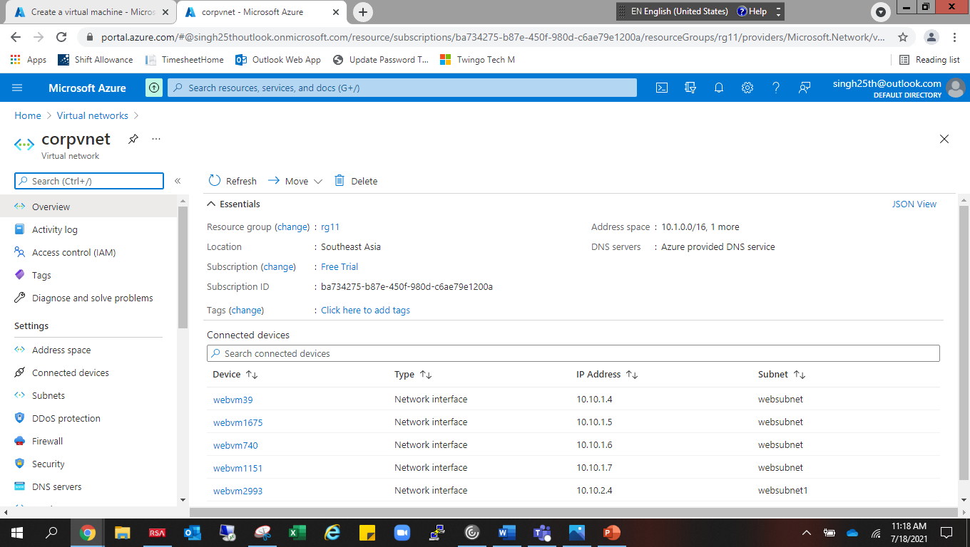

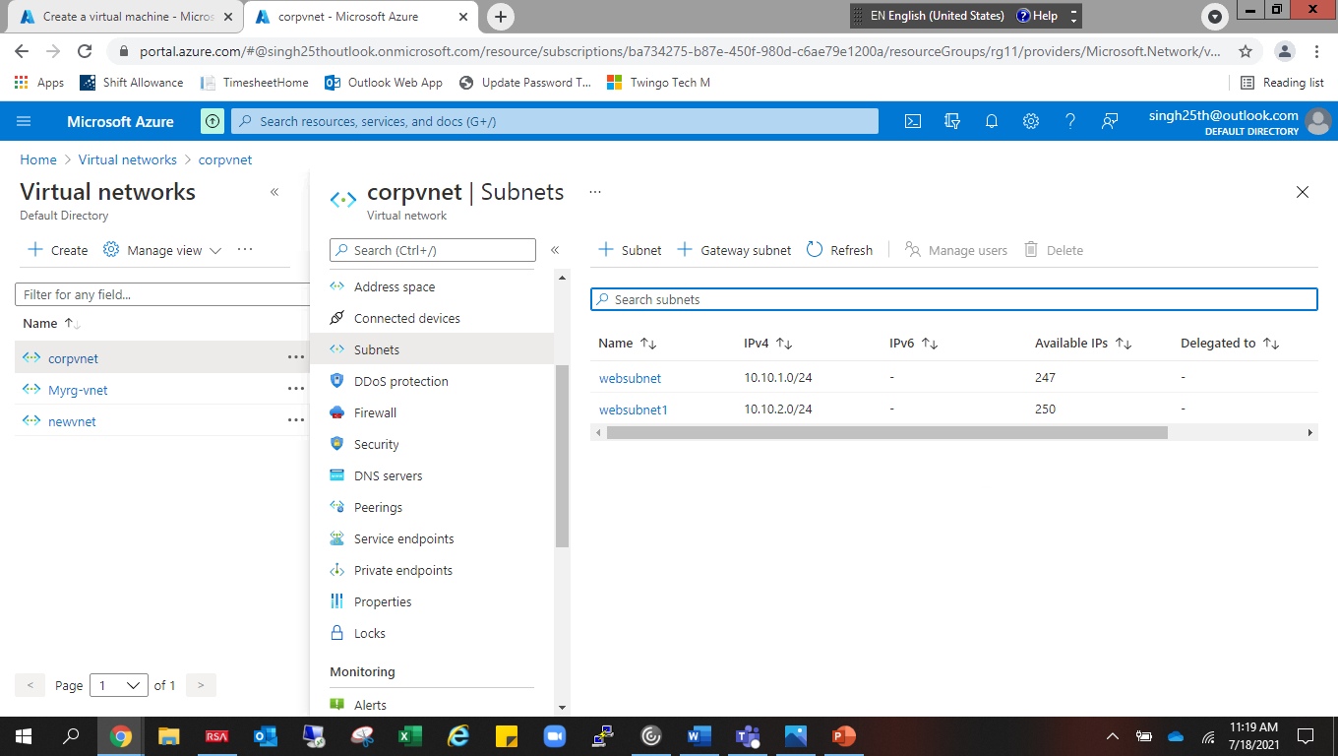

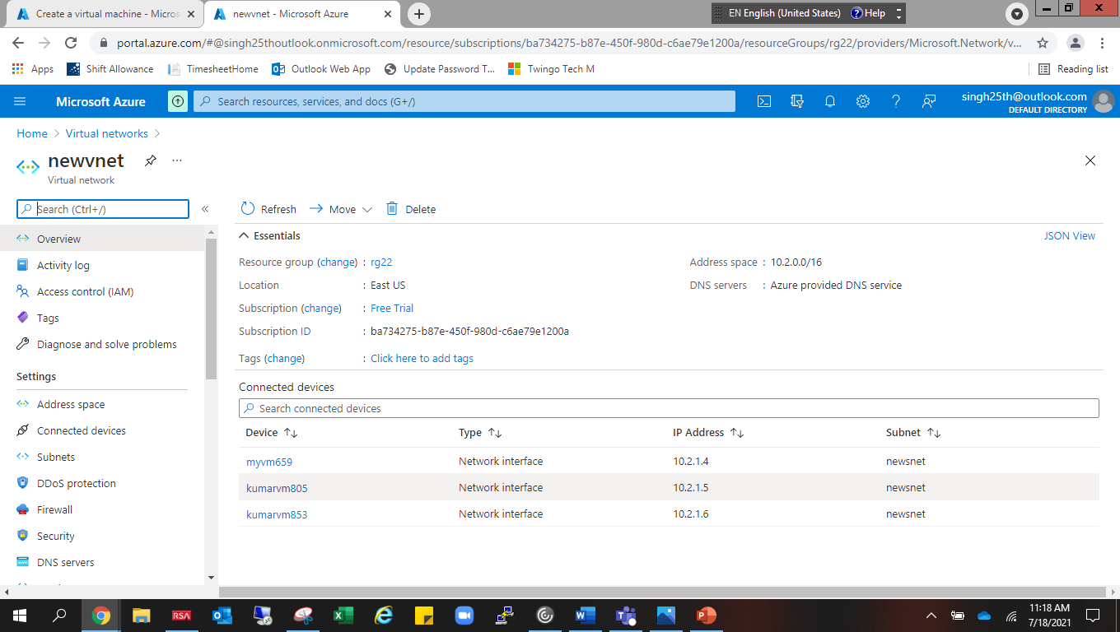

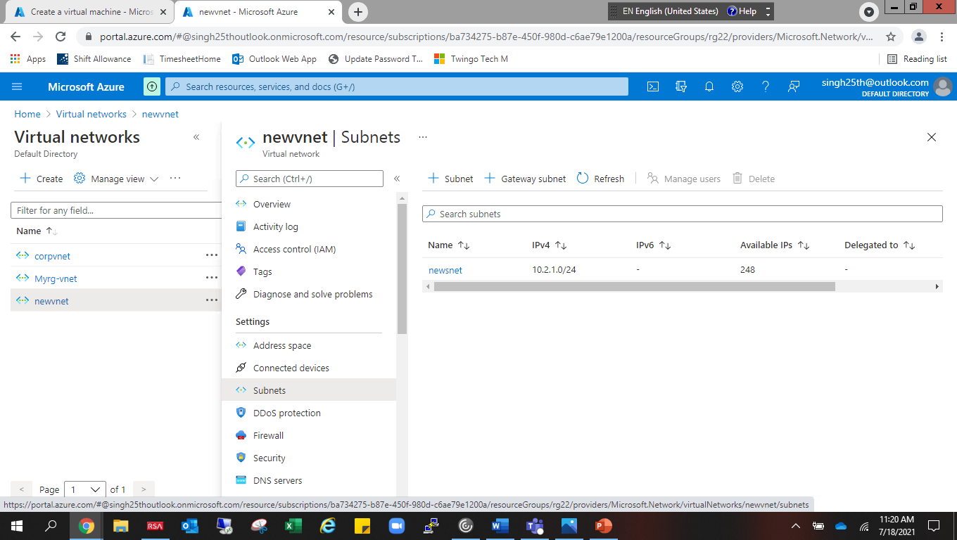

2. I have created 3 NSG.

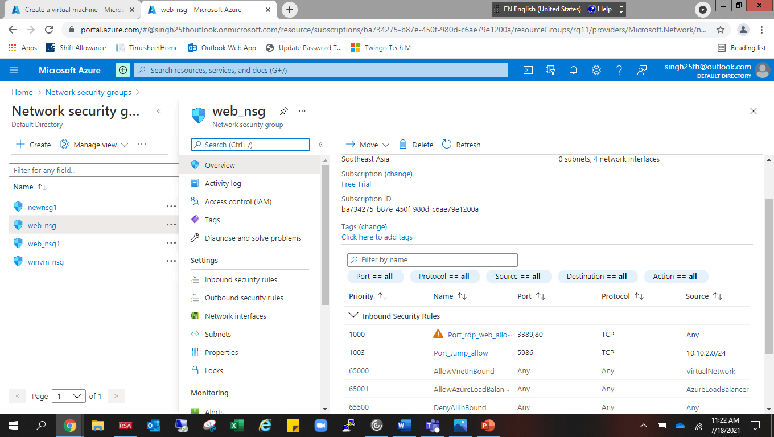

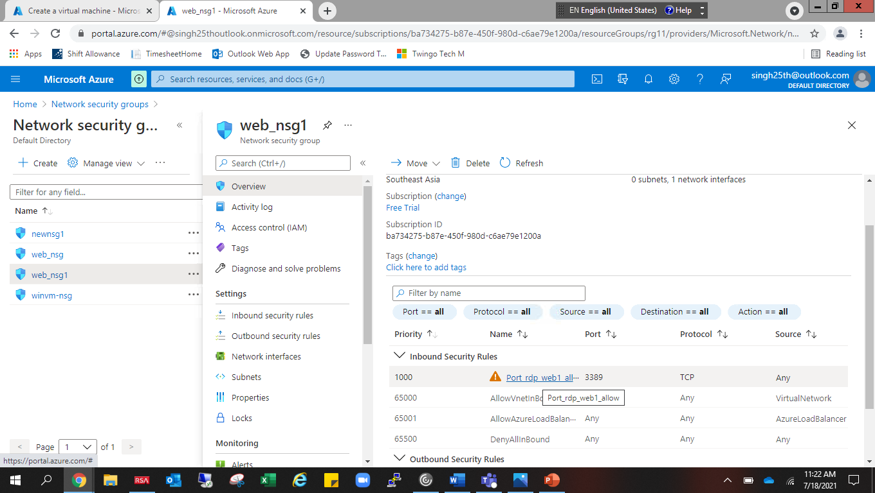

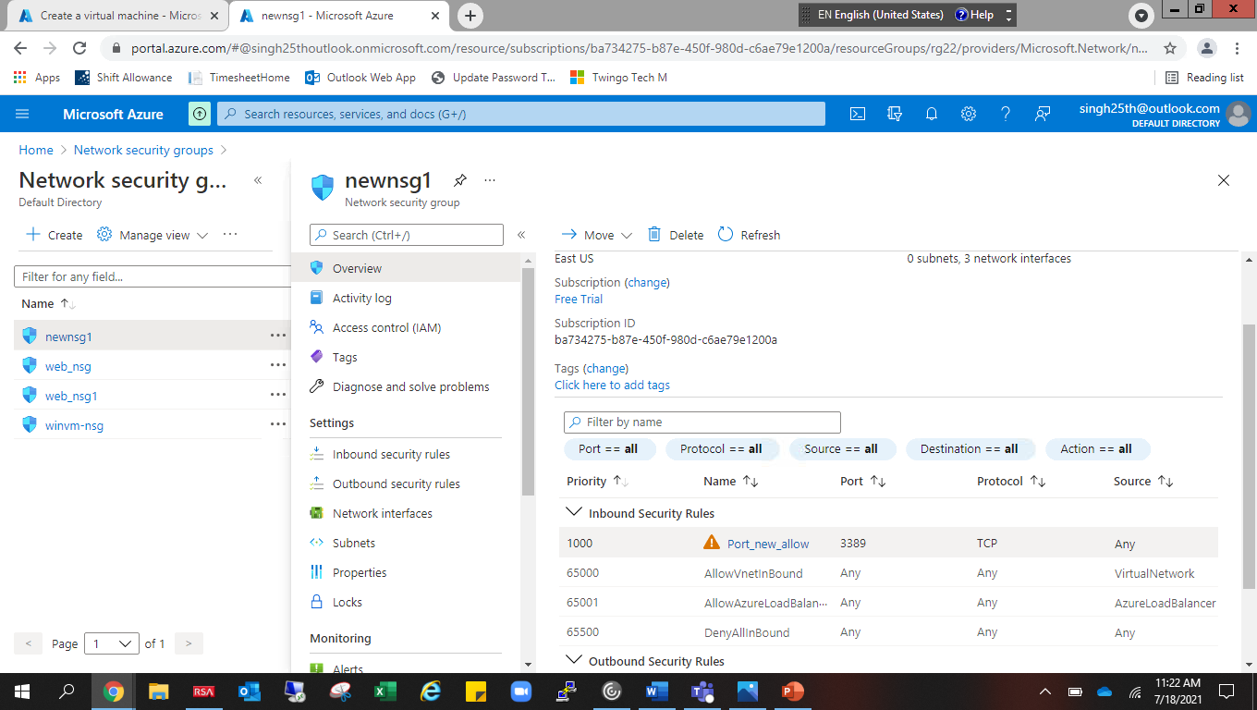

3. I have created 2 VM with availability set.

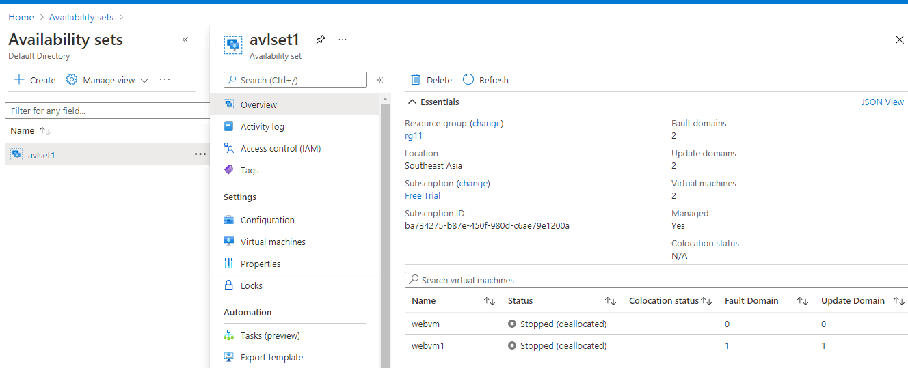

4. I have created one more vm without availability set.

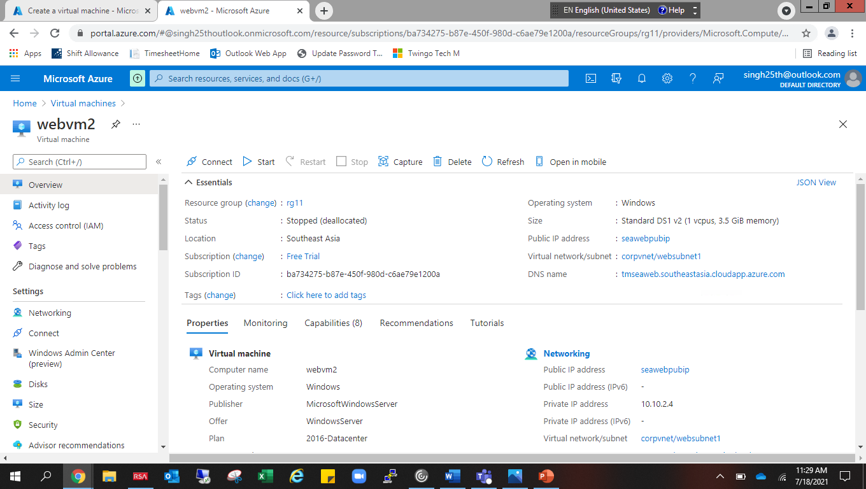

5.I have created one load balancer with frontend IP configuration, backend pool, health probes, Load balancing rule and inbound NAT rule.

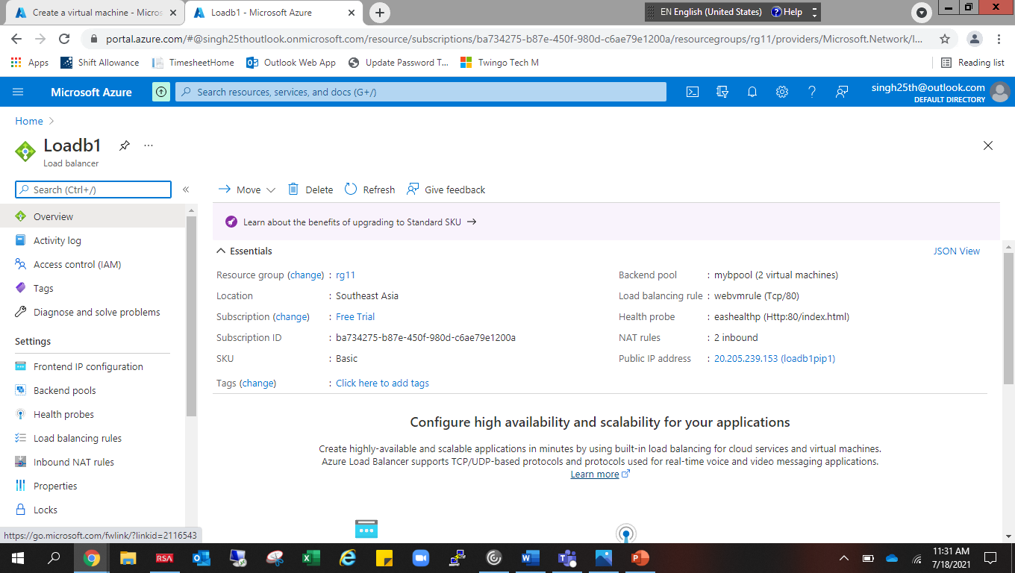

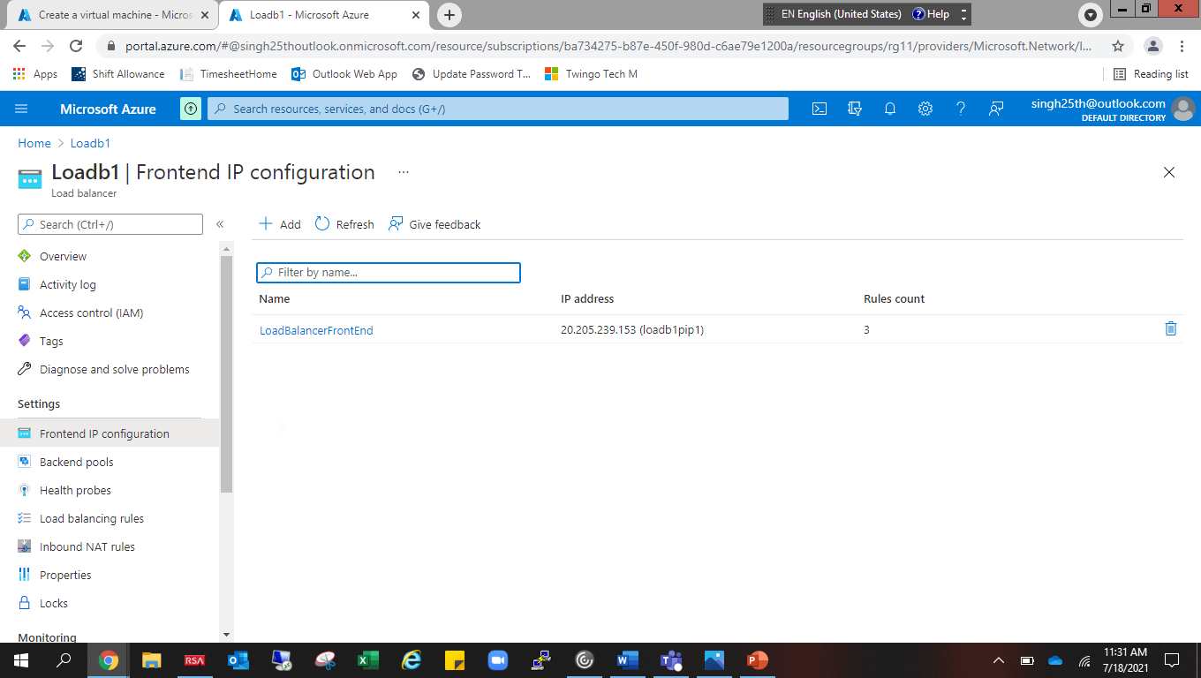

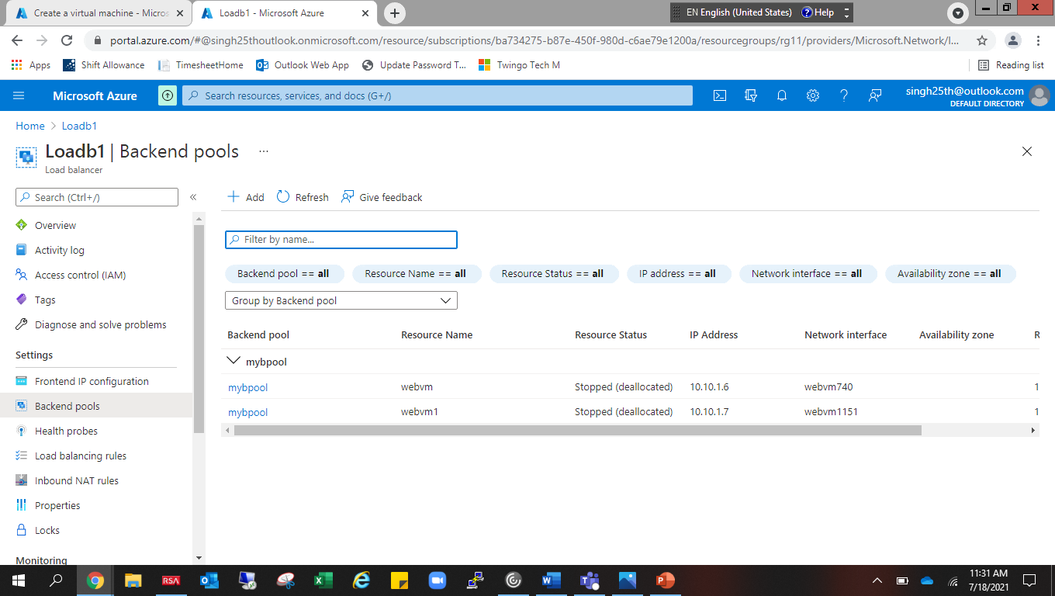

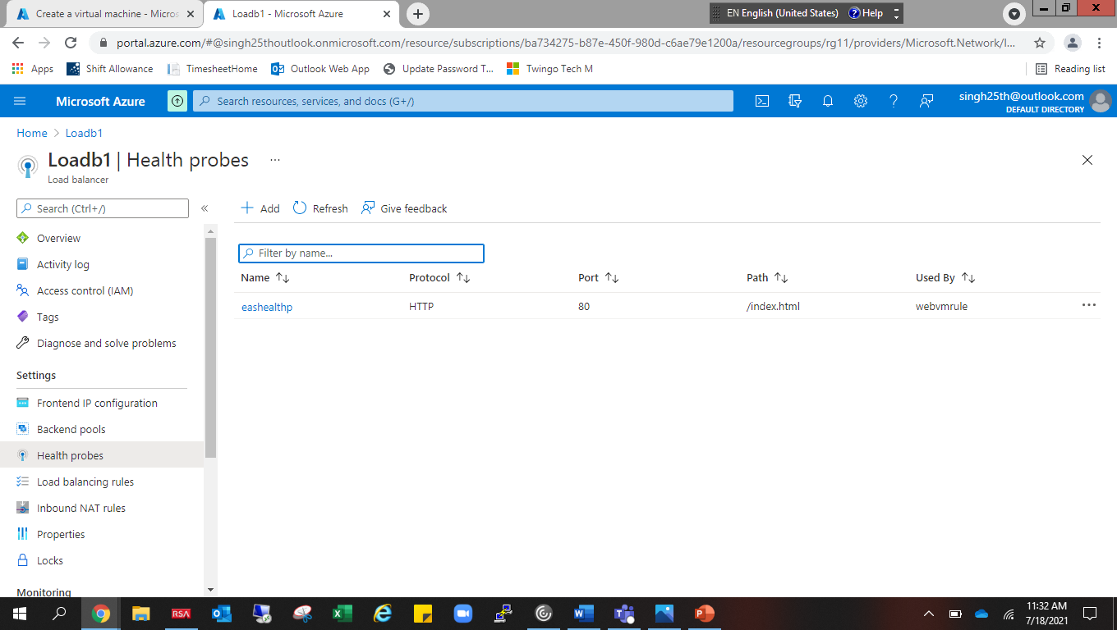

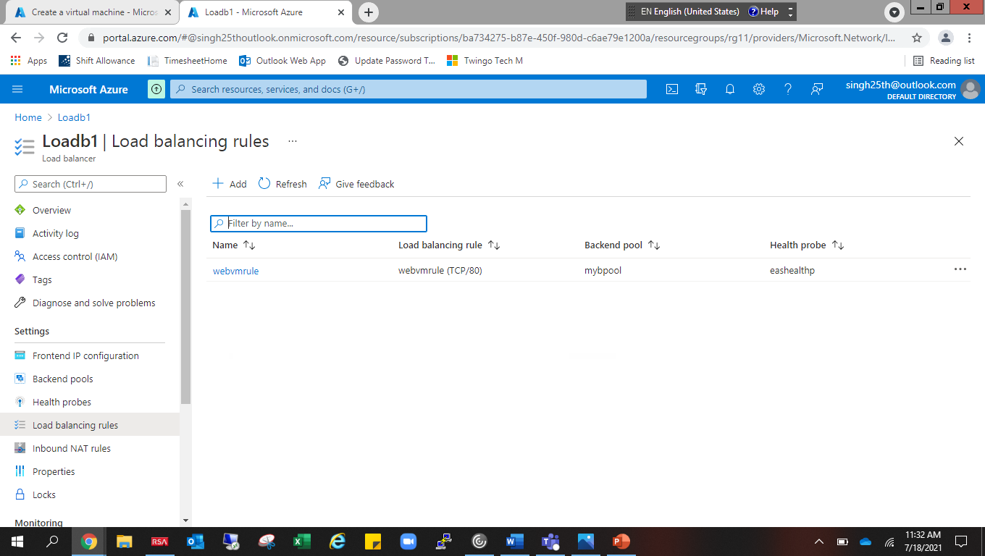

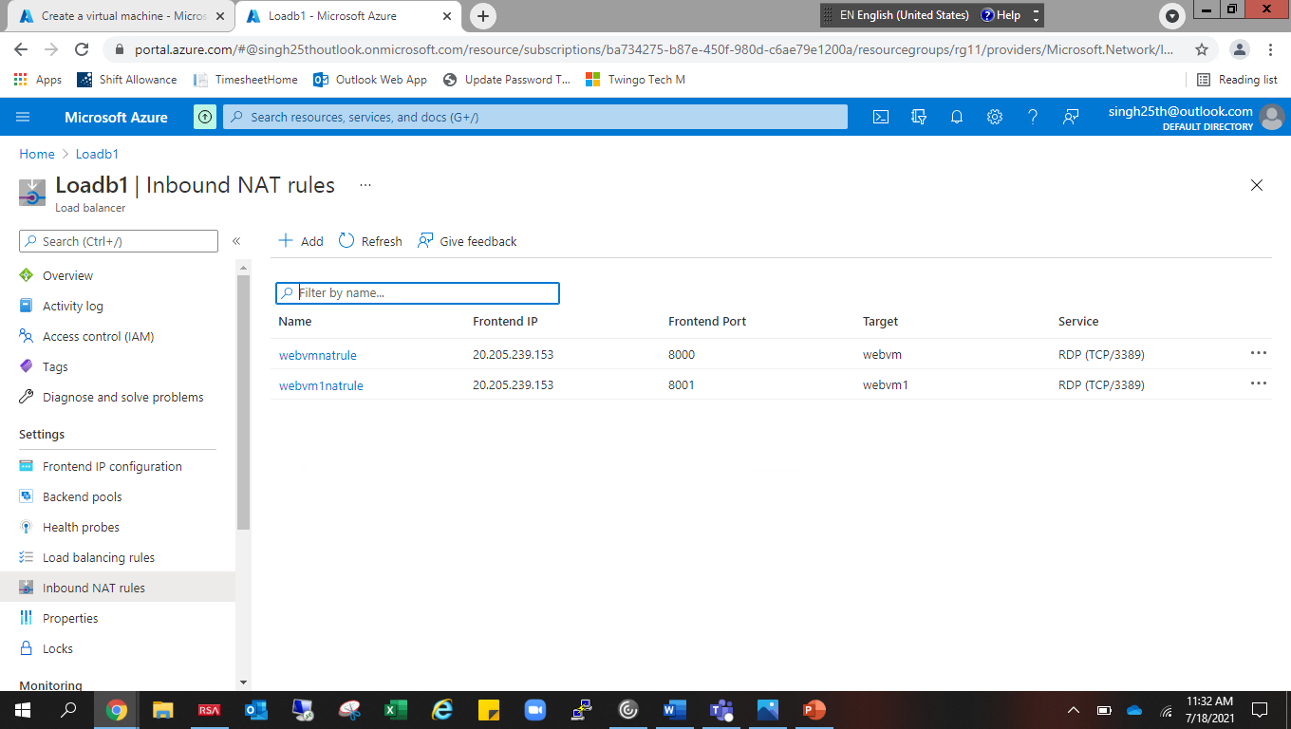

6. Tested the load balancer

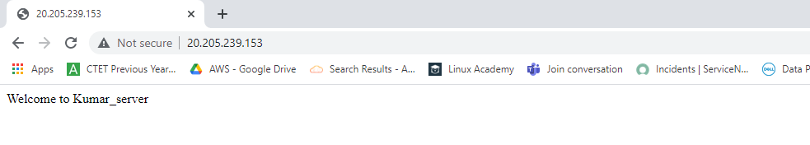

7. Server (kumarvm) is accessible via public ip from internet.

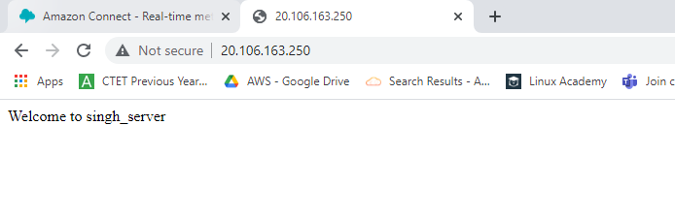

8. I have peered two virtual networks.

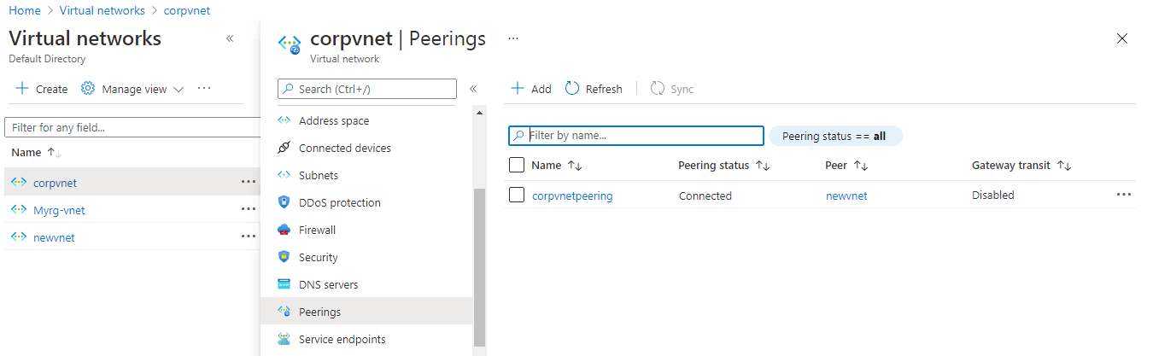

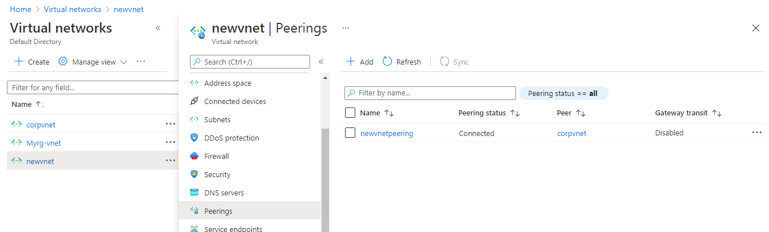

9. After peering I am able to take RDP through private ip from the SEA region server (webvm).

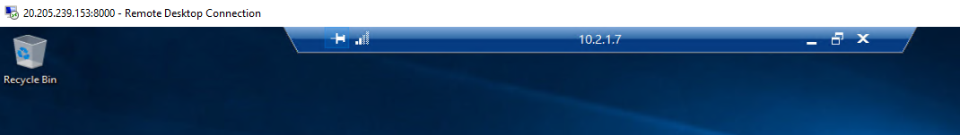

10.We have created two storage account in both region EUS and SEA





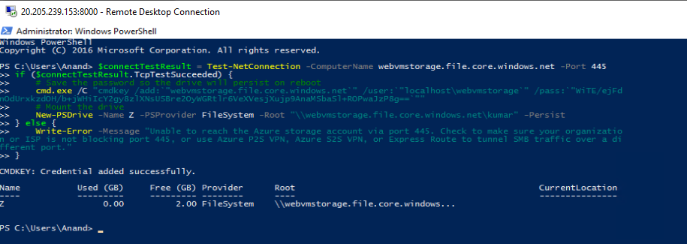

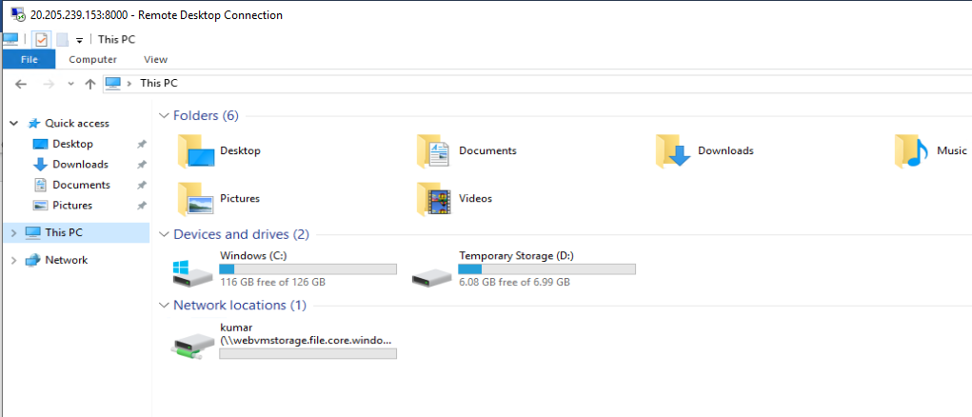

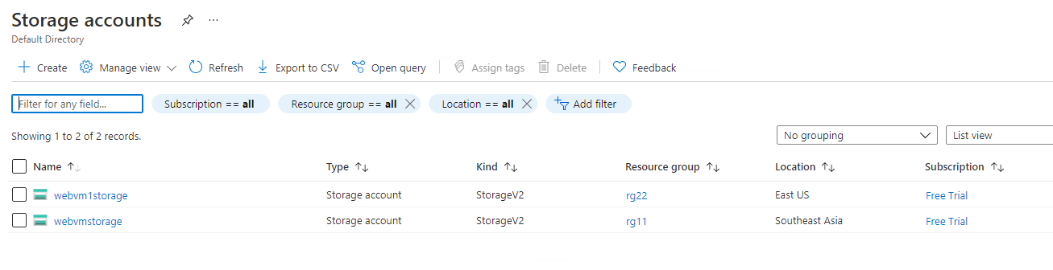

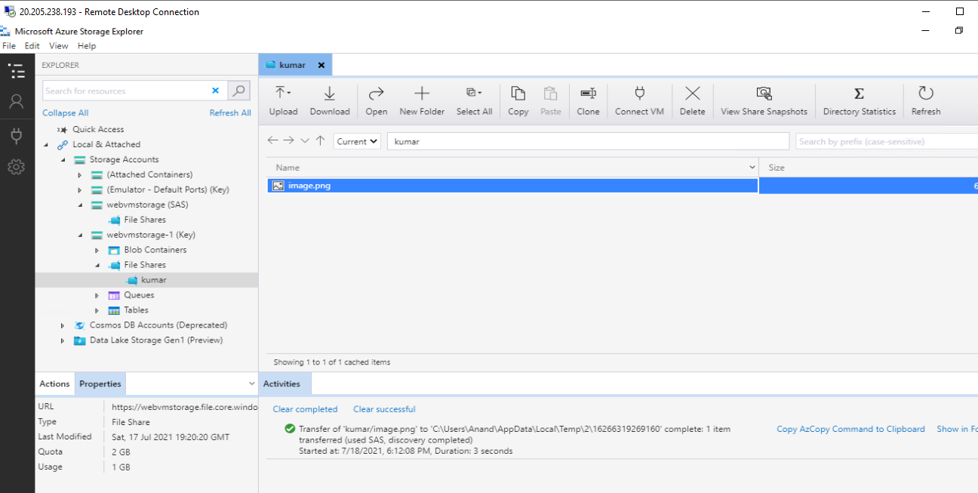

11. We have created alert in case of 80% above cpu usage.

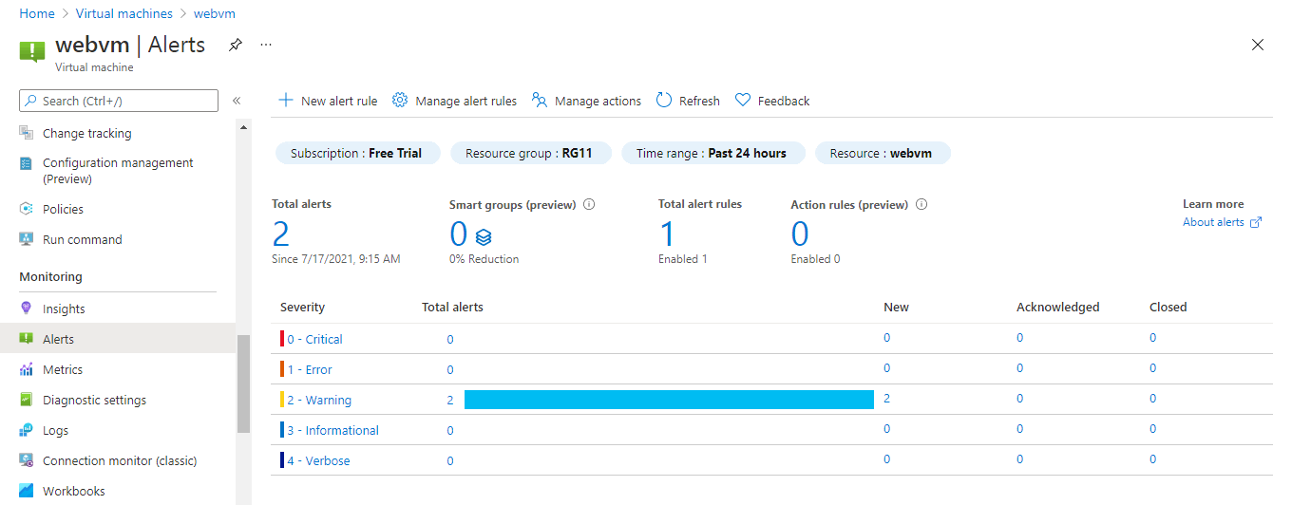

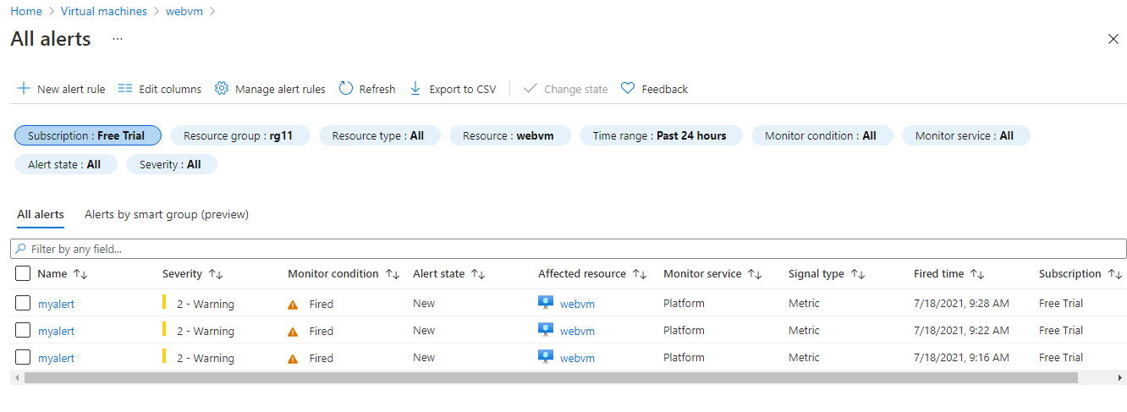

12. We have Enable backup for WebServers

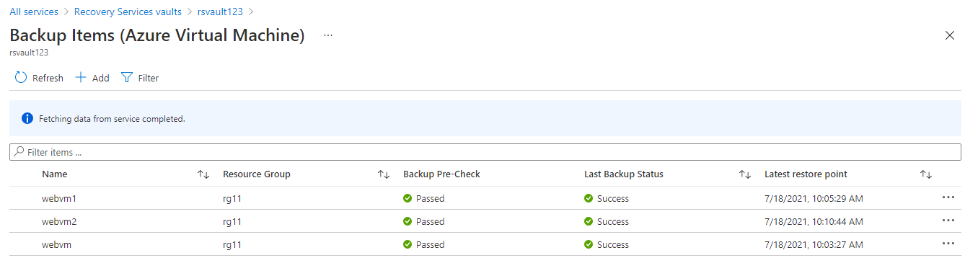

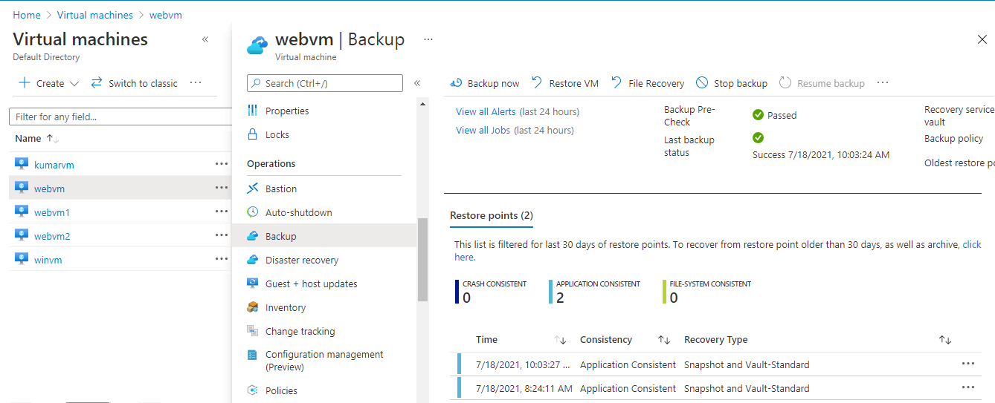

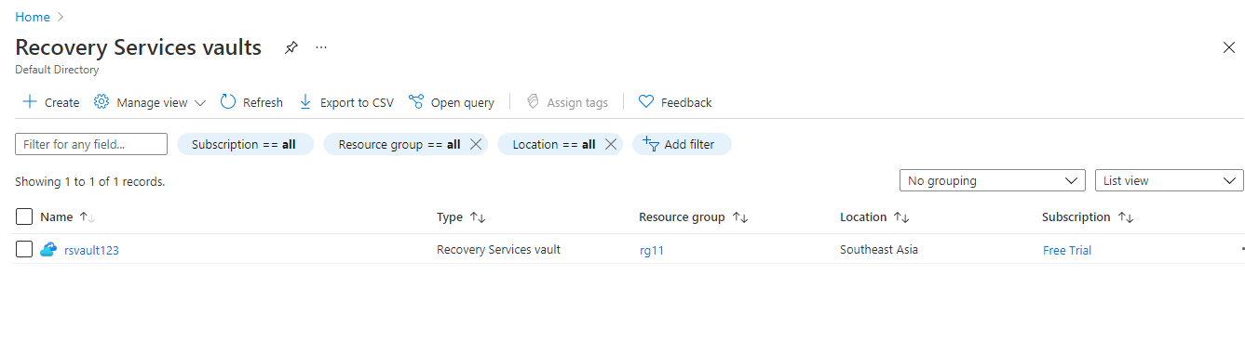

11. Below we have created Vmadmin user who is manage all VM in the subscription.

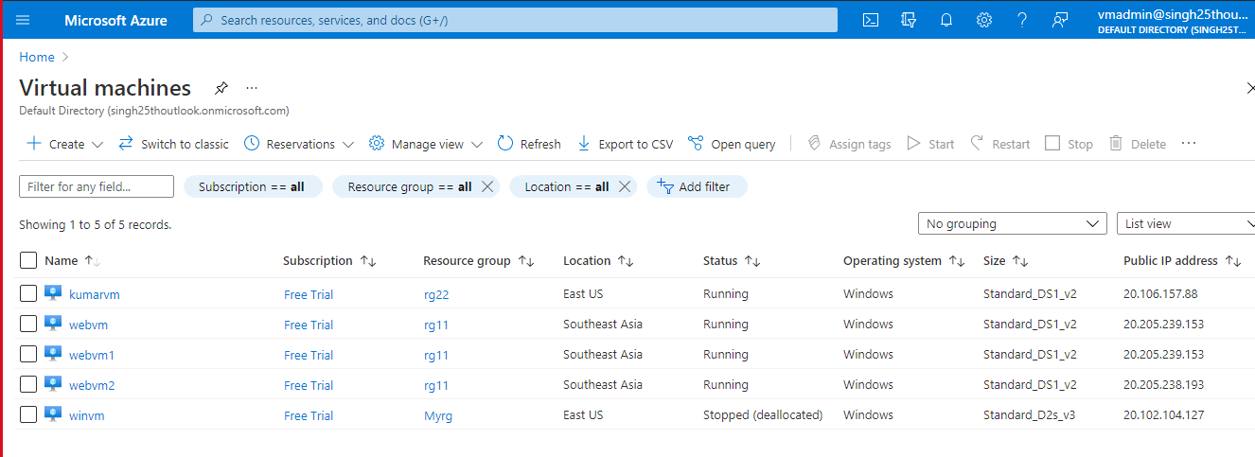

12. Below we have created Backup_admin user who is managing backup only in EUS servers in EURG.

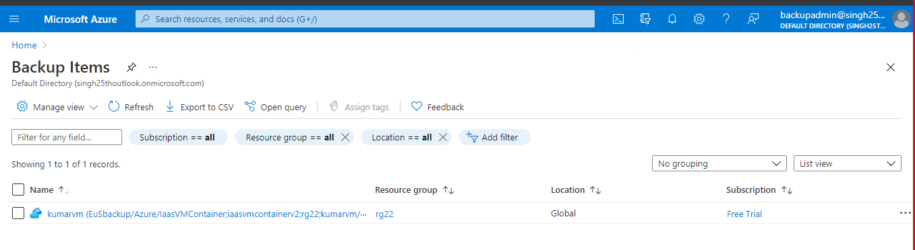

Implementation flow Diagram:

